**For the following question write the corresponding MongoDB queries**

Question1: Find all the information about each products.

Solution: db.products.find();

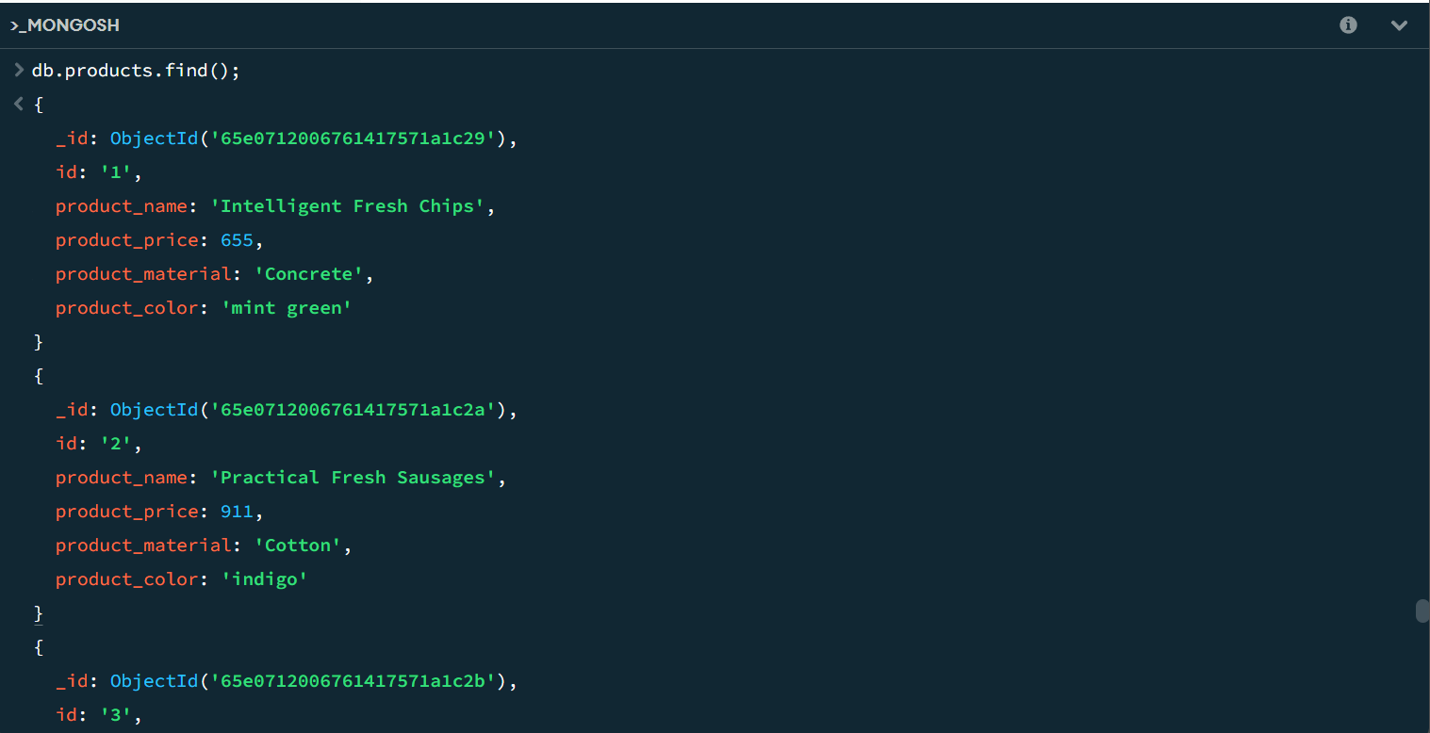

Question2: Find the product price which are between 400 to 800

Solution: db.products.find({product_price:{$gt:400,$lt:800}});

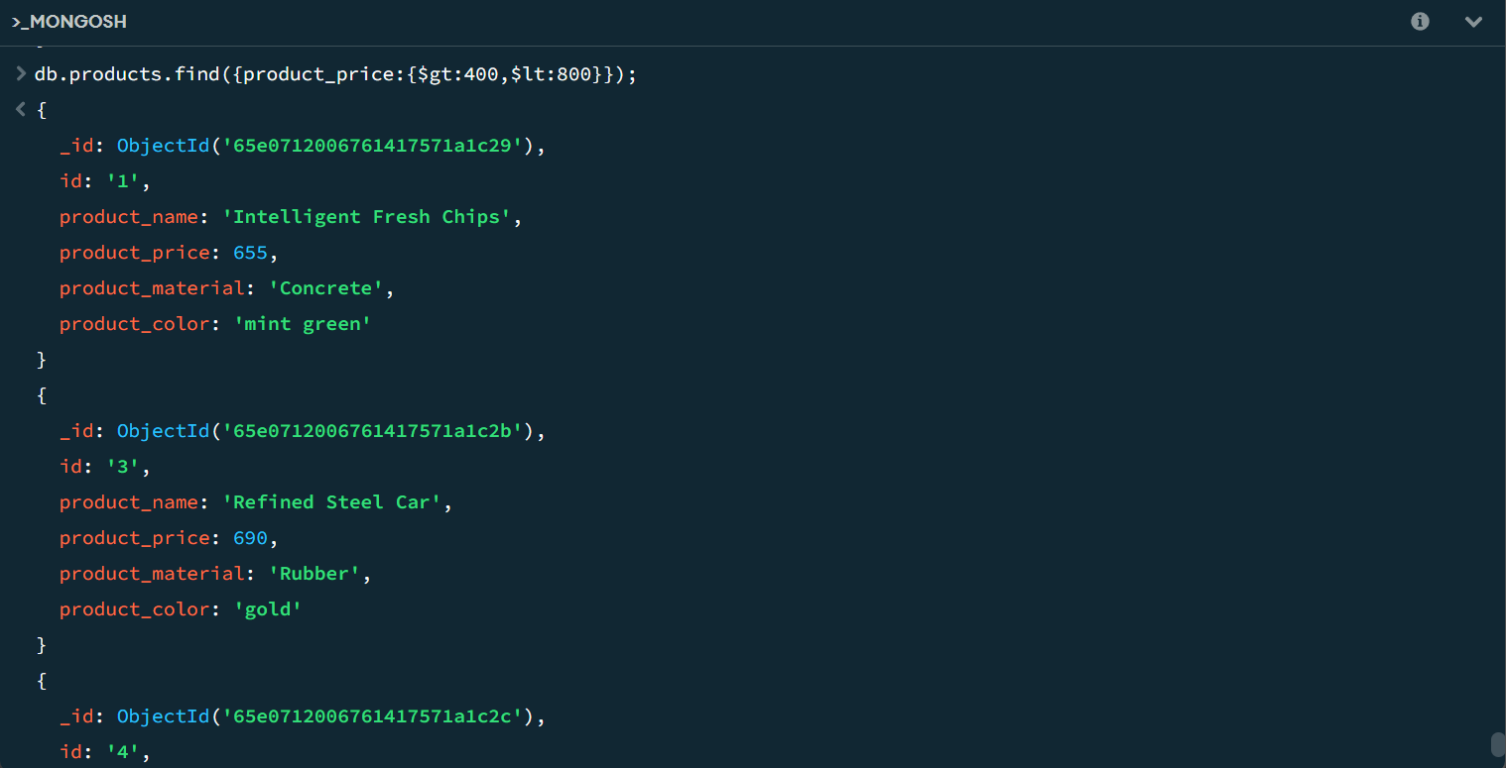

Question 3: Find the product price which are not between 400 to 600.

Solution: db.products.find({product_price:{$not:{$gt:400,$lt:600}}});

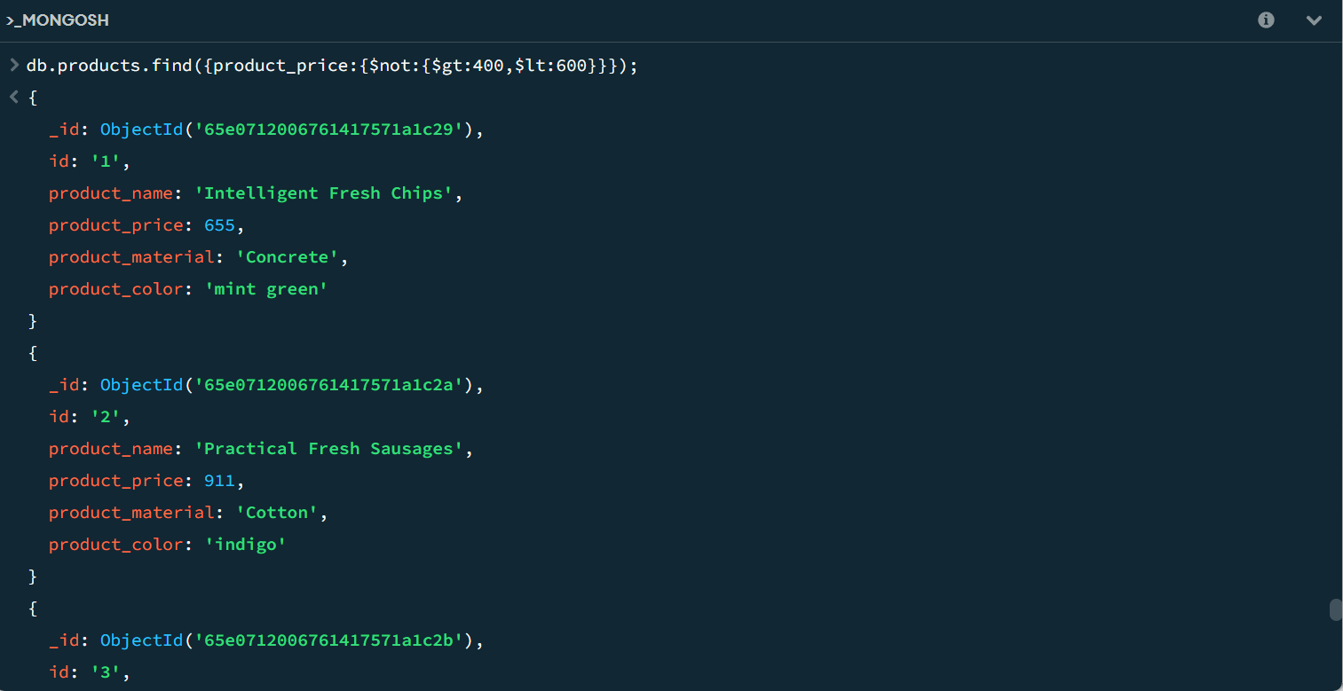

Question 4: List the four product which are greater than 500 in price.

Solution: db.products.find({product_price:{$gt:500}}).limit(4);

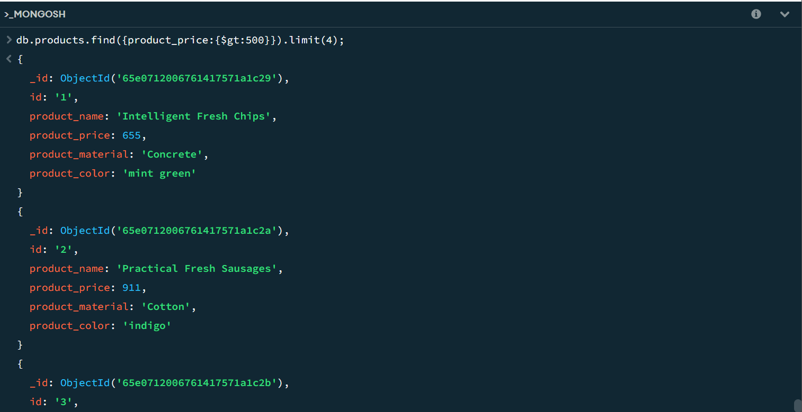

Question 5: Find the product name and product material of each products.

Solution: db.products.find({},{product_name:1,product_material:1});

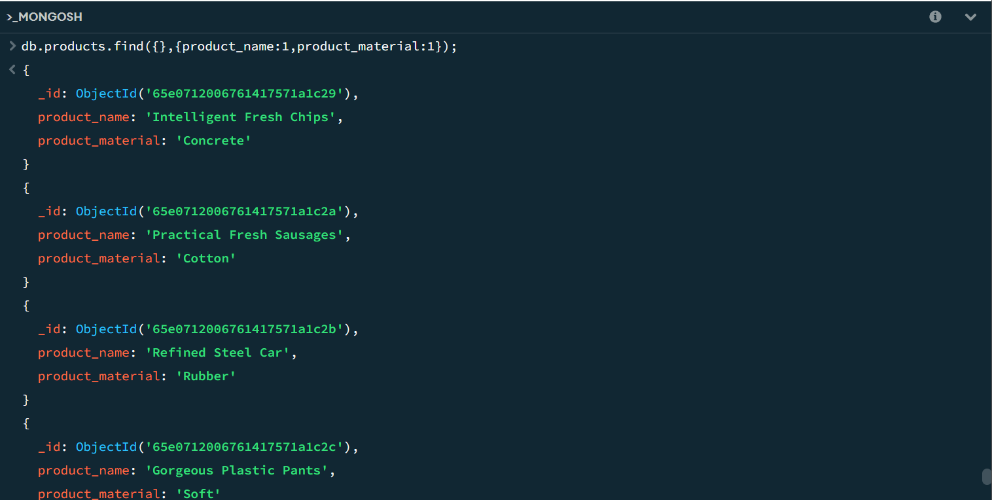

Question 6: Find the product with a row id of 10.

Solution: db.products.findOne({“id”:”10”});

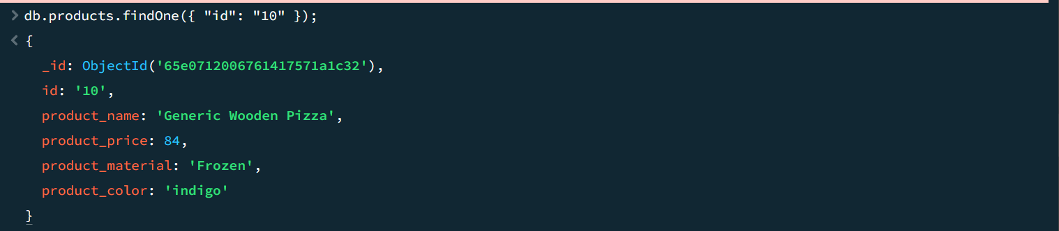

Question 7: Find only the product name and product material

Solution: db.products.find({},{product_name:1,product_material:1,_id:0});

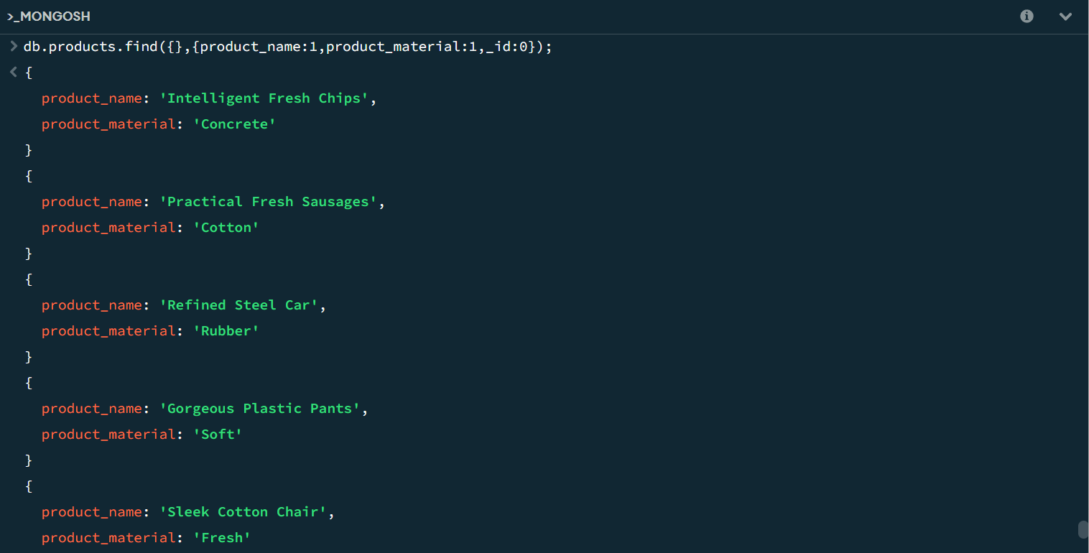

Question 8: Find all products which contain the value of soft in product material

Solution: db.products.find({ "product_material": /soft/i });

Question 9: Find products which contain product color indigo  and product price 492.00

Solution: db.products({ "product_color": "indigo", "product_price": 492.00 })

Question 10: Delete the products which product price value are same

Solution: db.products.aggregate([{$group:{_id:'$product_price',count:{$sum:1}}}, {$match: {count : {$gt: 1}}}]).forEach((e) => {db.products.deleteMany({product_price: e._id})});